Assignment (in a group of 4 members)
- Consider the following Circuit, by using Norton’s theorem.
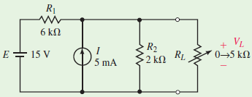
Find the Norton’s equivalent circuit
- Determine the value of load resistance required to ensure that maximum power is transferred to the load
- Find V_{L}, I_{L}, and P_{L} when maximum power is delivered to the load
- Repeat this question using Thevenin’s theorem. Hence show that these theorems are used in maximum power transfer theorem
- Use Thévenin’s theorem to determine the current through load resistor R_{L} for the following Circuit/5.
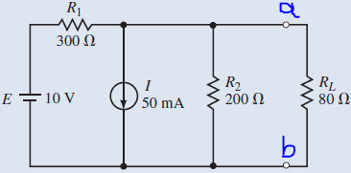
- Consider the Maximum Power transfer theorem and Calculate the Power that is supposed to be transferred to the load.
- What is the efficiency (η) at Maximum power?
- What is the efficiency (η) if the load is 100Ω?
- By giving examples, do a detailed research and discuss the tellegen's theorem used in circuit network analysis

